The problem we solve:
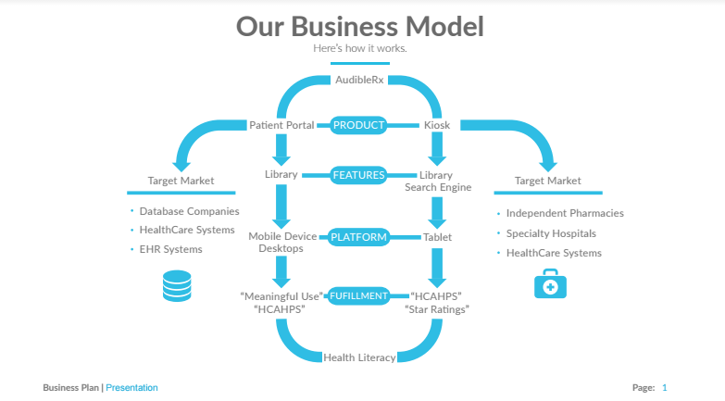
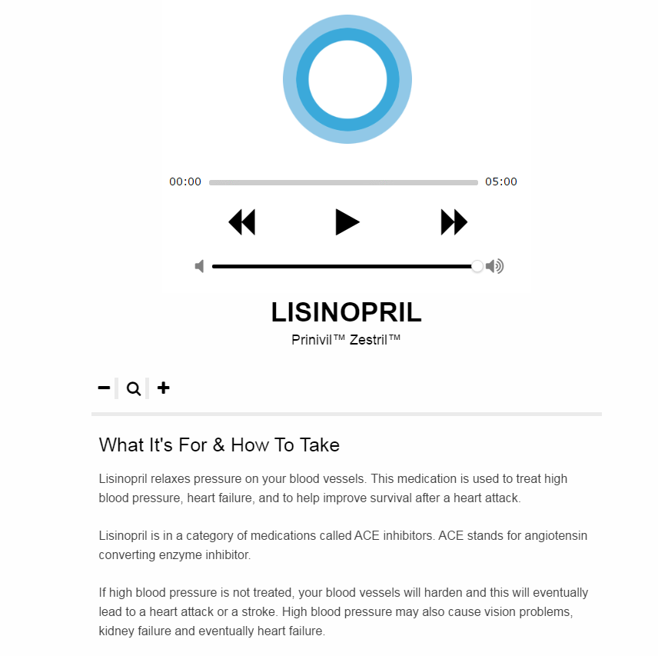

About Our Team

Creator: Steve Leuck
Education: University of the Pacific
Hospital Affiliation: Out-Patient Clinic Pharmacist
Title: President / Founder

About Team Members
Luka Tehovnik
Master of Pharmacy, Master's Degree
Biography: Luka received his Masters degree in Pharmacy from the Faculty of Pharmacy, University of Ljubljana. During his studies, he did a clinical pharmacy rotation in the US and later graduated in the same area. He now works in a pharmaceutical industry, gaining relevant experience in sales, marketing and medical field.
Twitter: @Pharmacist_Luka
LinkedIn: www.linkedin.com/in/lukatehovnik

About Our Company

AudibleRx, Inc.
Location: Santa Cruz, California
Website: http://audiblerx.com/
Twitter: @AudibleRx
Facebook: https://www.facebook.com/AudibleRx/
Other link: http://audiblerxbeta.com/prescription/lisinopril/
Product Stage: Prototype/MVP
YTD Sales: Working on it
Employees: 3-5

How We Help Patients
Consumers lack accessible and useful Consumer Medication Information knowledge in order to actively participate in their medication treatment.
In the United States, 36% of adults (approximately 115 million) lack the required health literacy to read or act on prescription labels, patient handouts, understand pharmacist counseling, or to convey their needs to the pharmacist.
Low health literacy is associated with poorer health outcomes and higher hospitalization and mortality rates, as well as an increased risk of adverse medication events.
AudibleRx helps patients increase their health literacy. This is done by providing an Accessible and Useful form of Consumer Medication Information that will actually help patients understand their medication.

How We Help Physicians
AudibleRx will bridge the medication education gap between consumer, pharmacist, and physician in consumer medication information (CMI) to improve outcomes, decrease medication “misadventures” and associated costs.
AudibleRx will improve patient experience and CMS 5 Star ratings performance by enhancing and increasing patient understanding of medications. AudibleRx will assist physicians and clinicians in achieving EHR goals as established by Medicare Access and CHIP Reauthorization Act (MACRA) of 2015 by improving patient engagement and use of "patient portal".
AudibleRx will place audio and visual CMI in patient portal to give patients access to their data while meeting requirements for secure messaging and patient data. AudibleRx will provide a tool to augment current practices in dissemination of CMI and establishing “best practice” for consumer medication education.
AudibleRx will improve health literacy in medication use by providing an alternative auditory model for consumer medication education in addition to text.

How We Help Hospitals
Bridge the medication education gap between consumer, pharmacist, and physician in consumer medication information (CMI) to improve outcomes, decrease medication misadventures and associated costs, including hospital readmissions.
Improve patient experience and HCAHPS performance by enhancing by increasing patient understanding of medications.
Assist in Meaningful Use attestation in accordance with American Recovery and Reinvestment Act of 2011 by improving patient engagement. MU2 states that education needs to be tailored to the learning needs of the patient and MU3 states that this education needs to be available to the patient through patient portal.
AudibleRx will place audio and visual CMI in patient portal to give patients access to their data while meeting requirements for secure messaging and patient data.
Provide a tool to augment current practices in dissemination of CMI and establishing “best practice” for consumer medication education.
Improve health literacy in medication use by providing an alternative auditory model for consumer medication education in addition to text.
AudibleRx is easily integrated into Electronic Health Record (HER) patient portal. End user (patient/consumer) can access individualized CMI via secured patient portal, thus improving electronic health information and patient engagement in accordance with Affordable Care Act (ACA) meaningful use guidelines.
The AudibleRx library content is uniquely compliant with existing standards and guidelines for CMI.

How We Help Partners

Supporters

Comments

